**IoT Experiment 5**

**Aim**: To study and install Raspberry Pi.

**Objective**: To study Raspberry Pi.

**Outcome**: Able to install Raspberry Pi and use it.

**Theory**:

**1**. What is Raspberry Pi?

The Raspberry Pi is a low cost, **credit-card sized computer** that plugs into a computer monitor or TV, and uses a standard keyboard and mouse. It is a capable little device that enables people of all ages to explore computing, and to learn how to program in languages like Scratch and Python. It’s capable of doing everything you’d expect a desktop computer to do, from browsing the internet and playing high-definition video, to making spreadsheets, word-processing, and playing games.

What’s more, the Raspberry Pi has the ability to interact with the outside world, and has been used in a wide array of digital maker projects, from music machines and parent detectors to weather stations and tweeting bird houses with infra-red cameras. We want to see the Raspberry Pi being used by kids all over the world to learn to program and understand how computers work.

**2**. Arduino vs Raspberry Pi

| **Basis** | **Arduino Raspberry Pi** |
| --- | --- |
| License | Arduino is an open-source project.  Both hardware and  Both its software and hardware  software of Raspberry Pi  design are open source.  are closed source. |
| Control Unit | From Atmega Family From ARM Family |

Clock

Frequency 16 MHz (Arduino UNO) Up to 1.5 GHz in Raspberry Pi 4 B

| RAM | Requires less RAM (2kB) Requires large RAM (more than 1 GB) |
| --- | --- |
| CPU  Architecture | 8-bit 64-bit |
| Logic level | Arduino’s logic level is 5V.Raspberry Pi’s logic level is 3V. |
| Power  Consumption  Based on  Hardware  Structure  Software | Consumes about 200 MW of power Consumes about 700 MW of power  Arduino is a Microcontroller Raspberry Pi is based on a microprocessor  Simple hardware structure Complex hardware Structure  Raspberry Pi supports its  own Linux-based operating  Arduino boards are programmable  system Raspberry Pi OS.  using C/C++ languages.  You can also install the OS  you like. |
| Internet | Arduino does not have internet  Raspberry Pi has a built-in  support. You need additional modules  Ethernet port and WiFi  or shields to connect it to the internet.  support. |
| Cost | Arduino boards are cheaper.Raspberry Pi boards are expensive. |

| How they handle power drop | Arduino devices begin executing  code when they are turned on.  Raspberry Pi requires the  Therefore, when power is turned off,  same care as a PC. You  abruptly, you won’t end up with a  have to shut the operating  corrupt operating system or errors.  system down properly.  The code will simply start again when  plugged in. |
| --- | --- |
| Current drive strength | Higher current drive strength Lower current drive strength |
| Capability | Raspberry Pi can perform  Arduino is generally used to perform  multiple tasks  single (and simple) tasks repeatedly.  simultaneously. |
| Wireless  connectivity | Arduino does not support Bluetooth  Raspberry Pi supports  or WiFi.  Bluetooth and WiFi. |
| Applications | Robot controller, Game  Traffic light countdown timer, Parking  servers, Stop motion  lot counter, Weighing machines, etc.  cameras, etc. |

**3**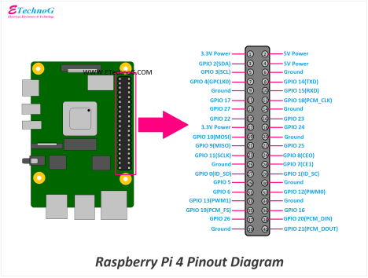. Pin diagram and Architecture

**4**. Real time example where we can use Raspberry Pi

There are several benefits of using a Raspberry Pi. Please find the below sections, where Raspberry Pi has been used widely and effectively. Below is the list of the top 10 uses of Raspberry Pi.

1. Desktop PC

Using Raspberry Pi, the microSD card, and a power supply, a simple desktop can be made. We would also need an HDMI cable and a suitable display, maybe an old monitor. A USB keyboard and mouse are also needed.

2. Wireless print server

This requires installing Samba file-sharing software and CUPS (Common Unix Printing System). CUPS provide drivers for the printer and administration console.

3. Media Usage

Many estimates suggest one of the main uses of Raspberry Pi is a Kodi media center. Several Kodi builds have been released as disk images. OSMC and OpenElec are among the most popular..

4. Game Servers

Raspbian, the default OS of pi, comes with a special version of Minecraft pre-installed. But, the applications of Raspberry Pi can be used as a game server as well. It is an excellent game server for Minecraft. If multiple Raspberry Pis are used, making one as a dedicated server, a great gaming experience can be achieved.

5. Retro Gaming Machine

Raspberry Pi is ideal as a retro gaming machine. it fits as one of the lightest components of a machine. Particularly, it’s a version, The Raspberry Pi Zero, that can fit into small spaces for gaming projects. There are two main options, Recalbox and RetroPie. Other platforms can be emulated too. Classic MS-DOS PC gaming and Commodore 64 can also be set-up and also many other popular 16-bit games consoles.

6. Robot Controller

There are many robot-controller Raspberry Pi projects. There is a dedicated robotics package for Pi, duly powered with the device battery and used to communicate and control robots.

7. Stop Motion Camera

Using Python and a suitable mount (standard tripod for clay- or toy-based) and the availability of a well-lit area Stop motion camera can be built. But, this is a time-consuming process. One needs a good amount of practice to get good results.

8. Time-lapse Camera Combining

The Raspberry Pi camera module indifferent script creates another use that captures movies. This can be achieved by taking single frames with a time delay. Also needed is, perhaps a portable battery solution, and a tripod can be used. A smartphone tripod is most preferred to ensure the device remains sturdy.

9. FM Radio Station

Raspberry Pi can also be used to broadcast on FM radio. Pi can broadcast only over a short-range. A portable battery and soldering skills may be required here. Any audio which needs to broadcast will need to be loaded beforehand to the microSD card.

10. Web Servers

Another great application of Raspberry Pi is to create a web server out of it. What this means is that it can be configured to host a website much like any other server. It can host blogs too. First of all, the right software needs to be installed and that is Apache and its dependent libraries. A full LAMP stack can also be installed with PHP, MySQL, and Apache too. Setting up FTP is also helpful.

Once all these steps as mentioned are completed, HTML files can be saved into the /www/ directory, and the web server is ready to be used. Specific web software like WordPress can also be used once the server setup is complete.

**Installation**:

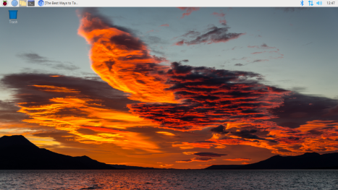

**Conclusion**:

The Raspberry Pi is a powerful little beast and a great platform for building low-cost, but highly capable, embedded systems. The interfaces built into its GPIO connector make it easy to bolt on modules using simple low-cost electronics and a bit of configuration to create very functional and flexible systems. Successfully installed Raspberry Pi OS in the Raspberry Pi module and tested it.